- Sort Persons by Name and Age
Create a class Person, which should have private fields for:
firstName: string
lastName: string
age: int
ToString(): string - override
You should be able to use the class like this:
StartUp.cs
public static void Main()
{
var lines = int.Parse(Console.ReadLine());
var persons = new List<Person>();
for (int i = 0; i < lines; i++)
{
var cmdArgs = Console.ReadLine().Split();
var person = new Person(cmdArgs[0], cmdArgs[1], int.Parse(cmdArgs[2]));
persons.Add(person);
}

persons.OrderBy(p => p.FirstName)
.ThenBy(p => p.Age)
.ToList()
.ForEach(p => Console.WriteLine(p.ToString()));
}
Examples
Input | Output
5  Asen Ivanov 65  Boiko Borisov 57  Ventsislav Ivanov 27  Asen Harizanoov 44  Boiko Angelov 35 | Asen Harizanoov is a 44 years old  Asen Ivanov is a 65 years old  Boiko Angelov is a 35 years old  Boiko Borisov is a 57 years old  Ventsislav Ivanov is a 27 years old

Solution
Create a new class and ensure proper naming. Define the private fields
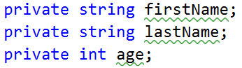

Create a constructor for Person, which takes 3 parameters firstName, lastName, age.
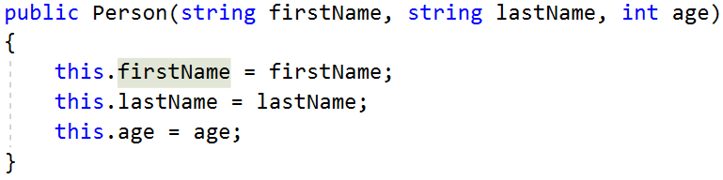
Create properties for these fields, which are as strictly as possible
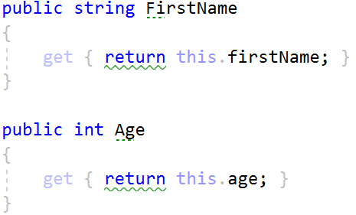
Override ToString() method:
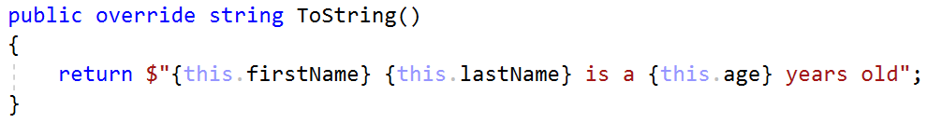
- Salary Increase
Refactor project from last task.
Read person with their names, age and salary. Read percent bonus to every person salary. Persons younger than 30 get half bonus. Expand Person from previous task. New fields and methods:
salary: double
IncreaseSalary(double bonus)
You should be able to use the class like this:
StartUp.cs
var lines = int.Parse(Console.ReadLine());
var persons = new List<Person>();
for (int i = 0; i < lines; i++)
{
var cmdArgs = Console.ReadLine().Split();
var person = new Person(cmdArgs[0],
cmdArgs[1],
int.Parse(cmdArgs[2]),
double.Parse(cmdArgs[3]));

persons.Add(person);
}
var bonus = double.Parse(Console.ReadLine());
persons.ForEach(p => Console.WriteLine(p.ToString()));
Examples
Input | Output
5  Asen Ivanov 65 2200  Boiko Borisov 57 3333  Ventsislav Ivanov 27 600  Asen Harizanoov 44 666.66  Boiko Angelov 35 559.4  20 | Asen Ivanov get 2640.00 leva  Boiko Borisov get 3999.60 leva  Ventsislav Ivanov get 660.00 leva  Asen Harizanoov get 799.99 leva  Boiko Angelov get 671.28 leva
Solution
Add new private field for salary and refactor constructor. Add new method, which will update salary with bonus
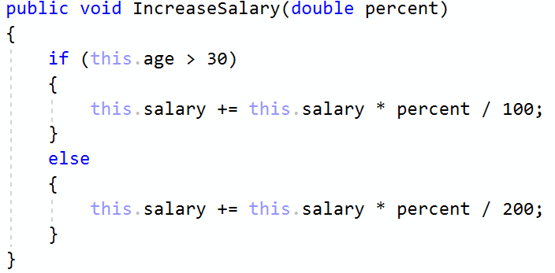
Refactor toString() method for this task.
- Validation Data
Expand Person with proper validation for every field:
Names must be at least 3 symbols
Age must not be zero or negative
Salary can't be less than 460.0
Print proper message to end user (look at example for messages).
Use ArgumentExeption with messages from example.
Examples
Input | Output
5  Asen Ivanov -6 2200  B Borisov 57 3333  Ventsislav Ivanov 27 600  Asen H 44 666.66  Boiko Angelov 35 300  20 | Age cannot be zero or negative integer  First name cannot be less than 3 symbols  Last name cannot be less than 3 symbols  Salary cannot be less than 460 leva  Ventsislav Ivanov get 660.0 leva
Solution
Add validation to all setters in Person. Validation may look like this or something similar:
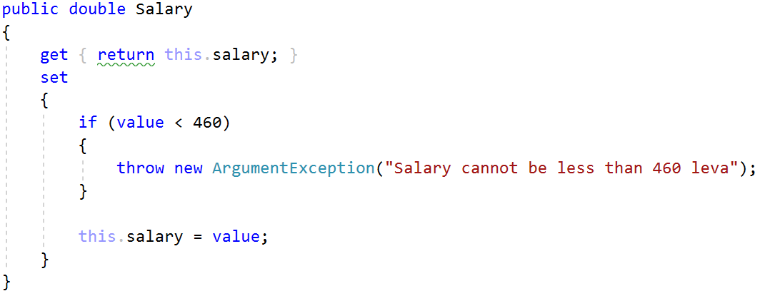
- First and Reserve Team
Create a Team class. Add to this team all person you read. All person younger than 40 go in first team, others go in reverse team. At the end print first and reserve team sizes.
The class should have private fields for:
name: string
firstTeam: List<Person>
reserveTeam: List<Person>
The class should have constructors:
Team(string name)
The class should also have public methods for:
AddPlayer(Person person): void
FirstTeam: IReadOnlyCollection
ReserveTeam: IReadOnlyCollection
You should be able to use the class like this:
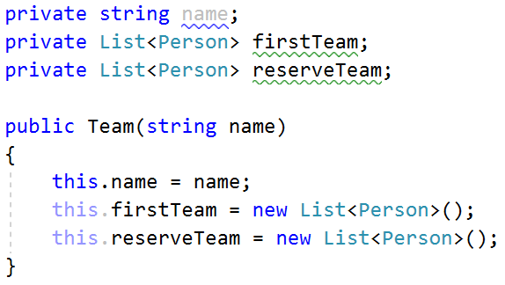
You should NOT be able to use the class like this:
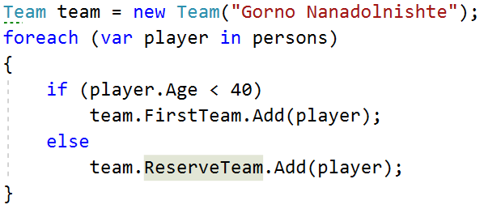
Examples
Input | Output
5  Asen Ivanov 20 2200  Boiko Borisov 57 3333  Ventsislav Ivanov 27 600  Grigor Dimitrov 25 666.66  Boiko Angelov 35 555 | First team have 4 players  Reserve team have 1 players
Solution
Add new class Team. Its fields and constructor look like:
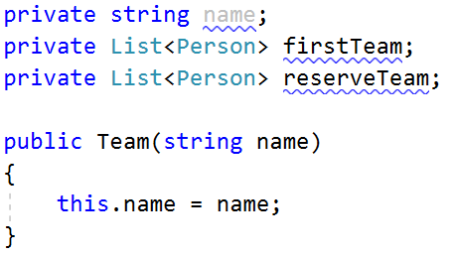
Properties for FirstTeam and ReserveTeam have only getters:
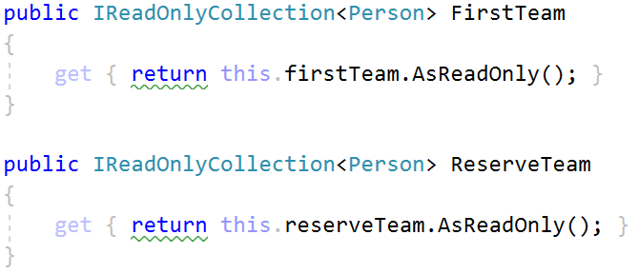
There will be only one method, which add players to teams:
